What we Do:  Sales & Service of Heating, Air Conditioning systems, duct cleaning, custom duct work & more!  Sales & service of Major Household Appliances! |  | - March – April 2020  - Bi-monthly Newsletter  25 N. 2ND ST  Black River Falls, WI 54615  (715)284-5931 Fax: (715)284-7142  Email: dalesref@dalesref.com  Web Site: www.dalesref.com
Happy Spring Monday – friday 8-12 & 1-5  Until further notice we will be closed Saturdays to help employees stay safe. |  | Closed Sunday’s & Holiday’s!

This is an unprecedented time in our history. The COVID-19 pandemic is having an impact on the health of our loved ones, the businesses we rely upon, the health of the global economy, and the way we live our daily lives. As we all continue to navigate through these unique and evolving challenges, we want you to know that Dale's Refrigeration & Heating is here for you.
In our more than 35 years of business, we’ve weathered with you the storms of the dot com bust, 9/11, the 2008 financial crisis and the recession that followed, major weather events — and throughout this shared journey we have worked to support and sustain our employees, our customers and our community. As we address a pandemic that will no doubt become a chapter in the history books, our commitment to you will not waver.
Thank you your support these past 35+ years and we look forward to serving you long into the future. Stay Safe during this shelter in home order and know that we are allowed to come and service your furnace, air conditioners and major household appliances.
Stay Safe! – Jill & entire staff at Dale’s!
Daylight savings is March 8, so our clocks will spring ahead an hour which is a sign that spring is just around the corner. We will be calling or sending out letters, once the weather is warm enough to schedule your annual central air conditioner clean & checks
Add duct cleaning to your spring cleaning list.
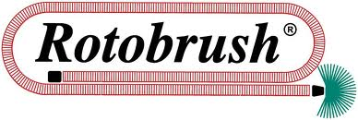
House all closed up for the winter - now would be a good time to get your ducts cleaned out. We use the Rotobrush cleaning system. The ducts are not only vacuumed cleaned but brushed clean! Call Dale’s Refrigeration & Heating for a FREE estimate. Why suffer when relief is just a phone call away!
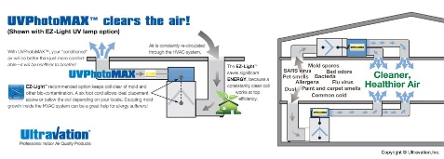
UltraVation Air Purification for HVAC system Kill airborne bacteria and viruses and reduce odors for cleaner indoor air with the UVPhotoMAX™ Signature Series for HVAC Systems
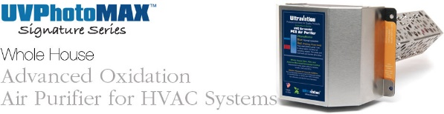
Indoor air quality
Now is the time of year to not only get the ducts cleaned but also to look into improving your indoor air quality! Whether it is a whole house filter system or electronic filter system. Give us a call for a free estimate in upgrading your indoor air quality
During this pandemic we will be practicing social distancing so if we stand back please do not be offended. We will be closed Saturday to reduce exposure times for employees. Questions – give us call

