Closing early for appliance training
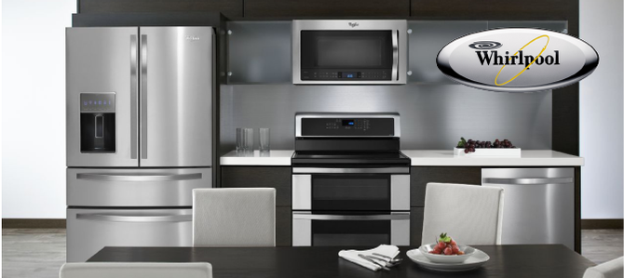  Whirlpool appliances |  | We will be closing early on Thursday September 6, 2018 for appliance training.  We will close at 10 AM to give us travel time to our training. We apologize in advance for any inconvenience this may cause. Please call the store and leave a message and we will return your phone call our next working day.  715-284-5931
September 6, 2018 10 AM
Dale’s Refrigeration & Heating, Inc.
25 N 2nd ST, Black River Falls, WI 54615
715-284-5931 | dalesref@dalesref.com | www.dalesref.com

